**HIT Projects Center  
(Specification document)**

[https://hit-projects-center.com](https://hit-projects-center.com/)

**introduction**  
hit projects center is a management system for every project that comes out of the institute.  
The site allows for full management, supervision and control of student progress, registration, statistics, tracking, uploading products, and more.

**The purpose of the document: is to provide a complete characterization of our website.  
While presenting the value to the organization and the Technological Institute.  
The document presents: technical details, user interface, integration points, functionality, security considerations, deployment strategy and any relevant legal or regulatory requirements.**

**Including: This document contains the entire scope of the project set, including the target audience, platforms, architecture, data management, performance, accessibility, and maintenance.**  
 **App Review  
Target Audience/Users: The website development is designed to provide a solution for the program's instructors, administrators, coordinators, and students.  
Website users: admin, instructor, student.**

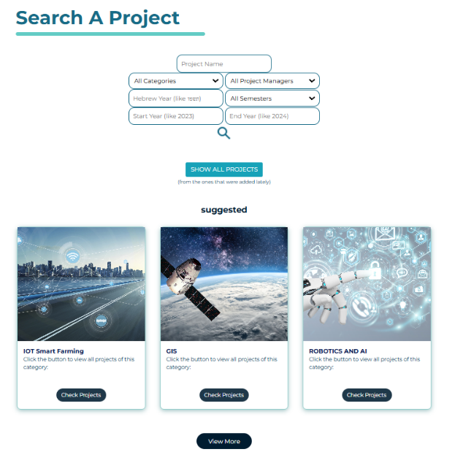**Main features**

**Feature 1:** Project presentation.  
  
This feature allows users to be interested in new projects offered by the institute.  
On the first page (in the picture), you can search for projects that have been completed at the college.  
There is an option to search by: category, year, name, supervisor, and more.  
The finished project page shows projects that have products. That is, files have been uploaded to the site and there is a GIT link where you can access the product.

The site also serves as an archive and reference system for projects that have already been completed at the institute. Thus, anyone can log in and see the impressive products of the students at the institute.  
Students can also access and see the products of other students, and thus be impressed by the experience that can be gained by participating in the project.  
As part of submitting the products, students are now required to also submit a presentation and a YouTube video, in order to easily present the project on the site.

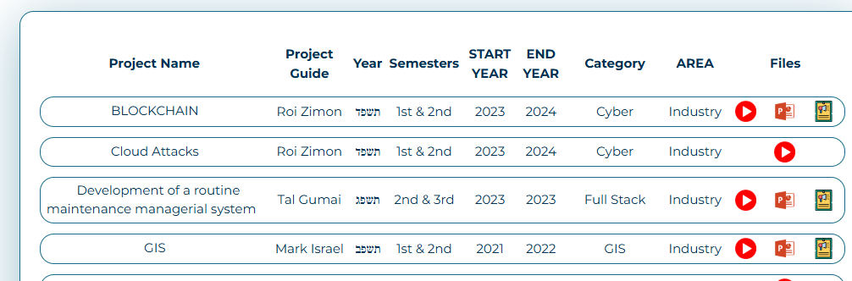

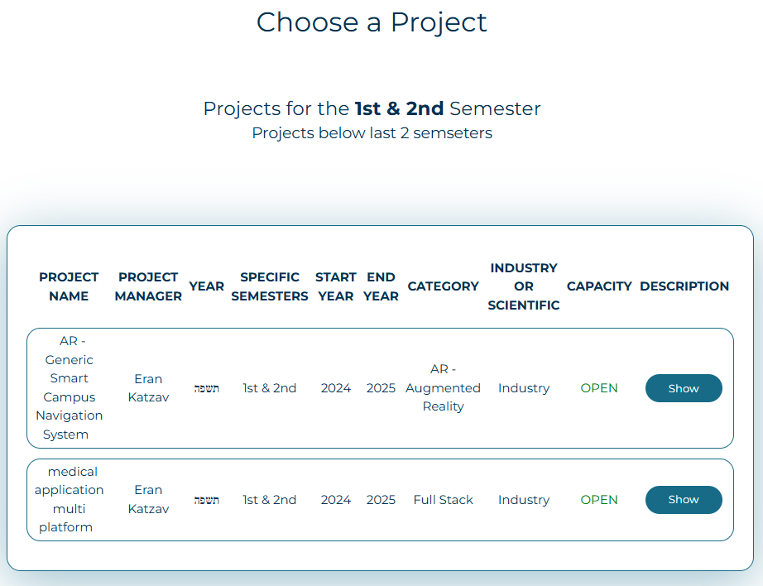

**Feature 2:** Showing new projects before registration.  
  
A few weeks before the start of the semester, you can open the available projects page and see what new projects have been uploaded. In the tables you can see who the supervisor is, and to which category the project belongs. Student that interested in a project in a specific field, can choose to show only projects in his field of interest.

**Feature 3:** Project Registration.  
  
The system allows students to open a user on the sign up page or through the available projects page while reading the proposed projects.  
After registration, all of the student's information is associated with the project they have chosen. As long as the project is still proposed, the student can cancel his registration on "my projects" page. In accordance with the institute's procedures - a student will not be able to register for 2 projects at the same time, the system will prevent him from doing so).  
The security mechanisms of the projects website will store an encrypted version of the student's password, in order to increase security and protect the student's private information.

**Feature 4:** Student Profile.

A registered student can log in to the my projects page and see the projects they are associated with, and the assignments they have received.  
In addition, the student must report attendance at team meetings through this page.  
If there is a meeting in the project at the moment, the page will show them the attendance mark button.

**Feature 5:** Project Management.

An Admin user can edit a project - add and delete projects, and decide on the association of a supervisor to the project.  
A supervisor can only edit projects that are associated with him.  
The manage projects page displays all projects.  
There you can download an excel of all registrations by semester and year.  
You can also search for a project by various criteria.

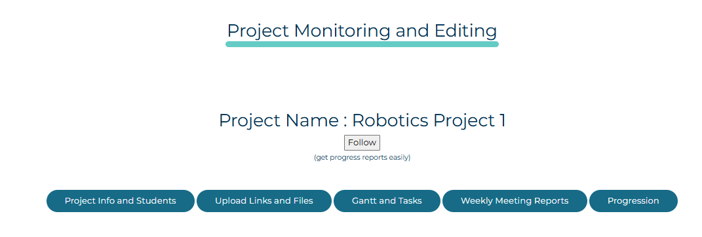**Feature 6:** Project Editing.

Clicking on the project row opens the project management page. Project management is divided into tabs.

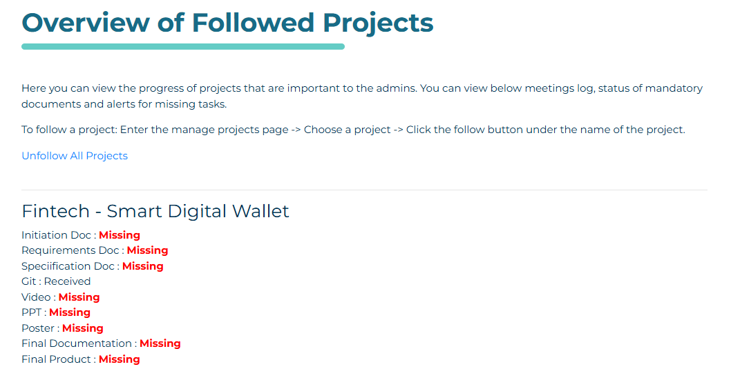

The FOLLOW button tracks the project. It will be easy for managers to track the upload of deliverables and documents.  
To get there, go to MANAGE PROJECT and then to PROGRESS REPORTS -

And this is how it looks:

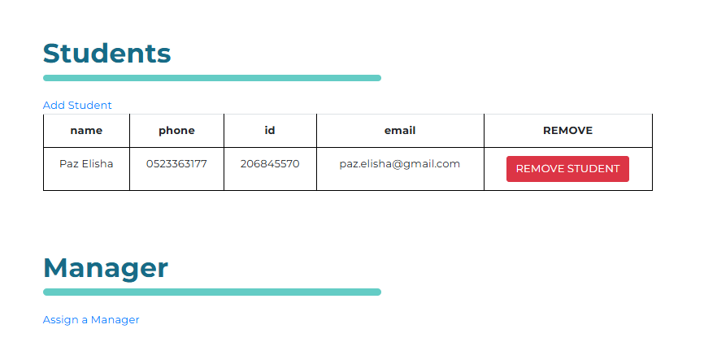

**Feature 7:** Information - INFO.

Here you can edit the information about the project, see who the participants are and who the lecturer is.

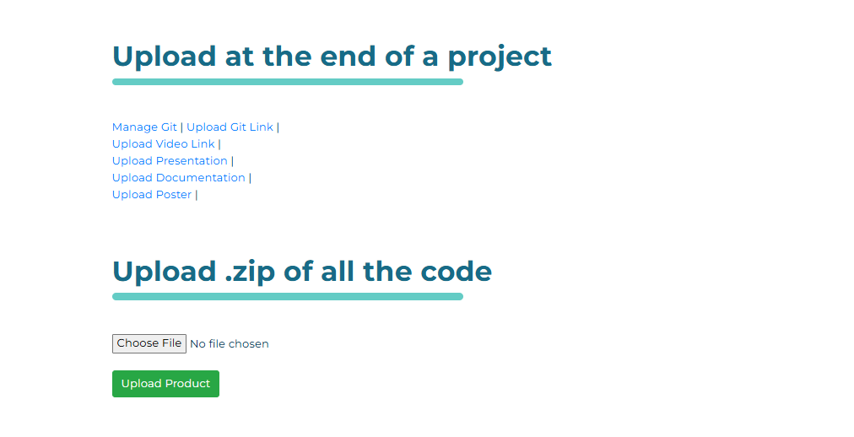

**Feature 8:** Files - FILES.

On this page you can upload all the project files and a ZIP- with the final product.

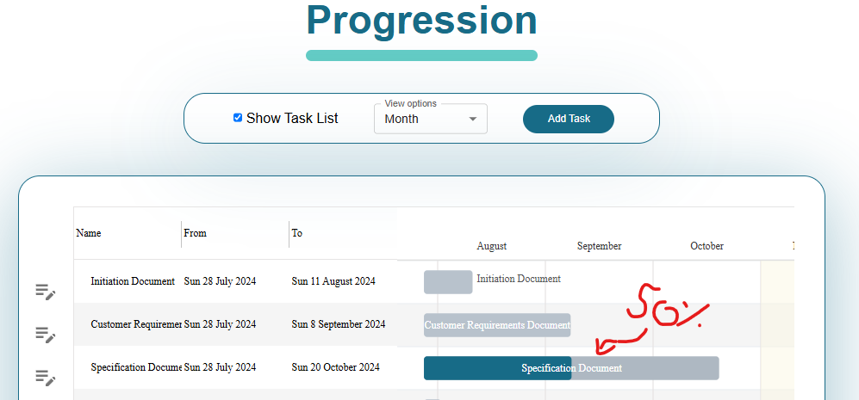**Feature 9:** Tasks and Gantt - TASKS AND GANTT.

In Gantt - you can see and edit visually all the tasks until the project end. You can drag the PROGRESSION of each task. If for example 50% of the task is completed - you can see this in the Gantt. This part is very significant for tracking the progress of the project - for the institute and partnership company.

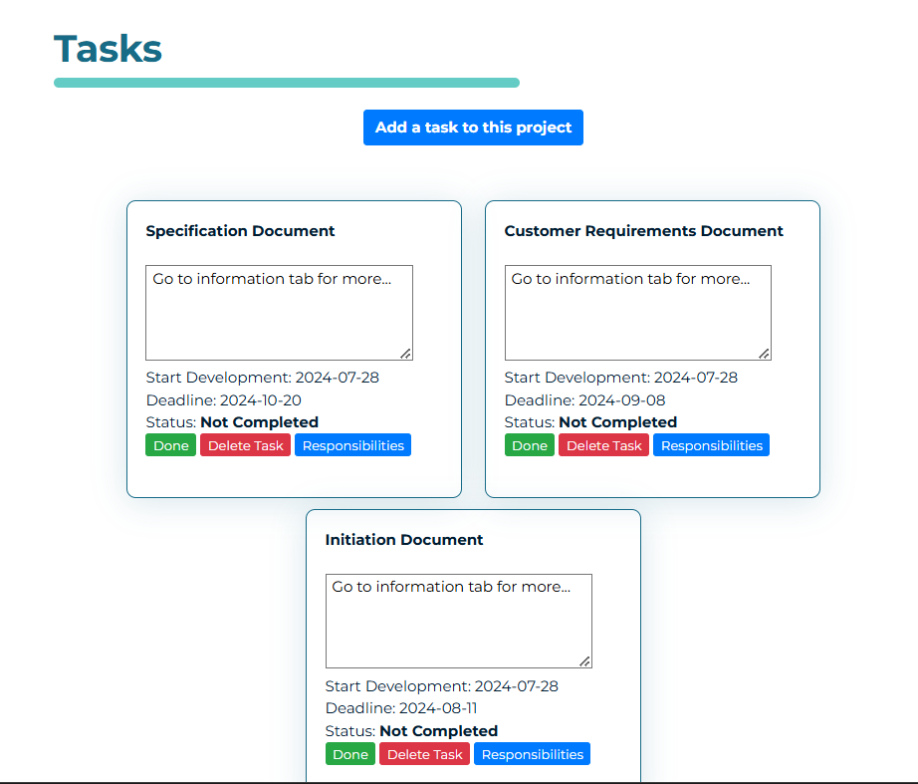

**Feature 10:** Cards

Each task has a card so you can know if the task has been completed, you can also assign a task to a student/delete a task.

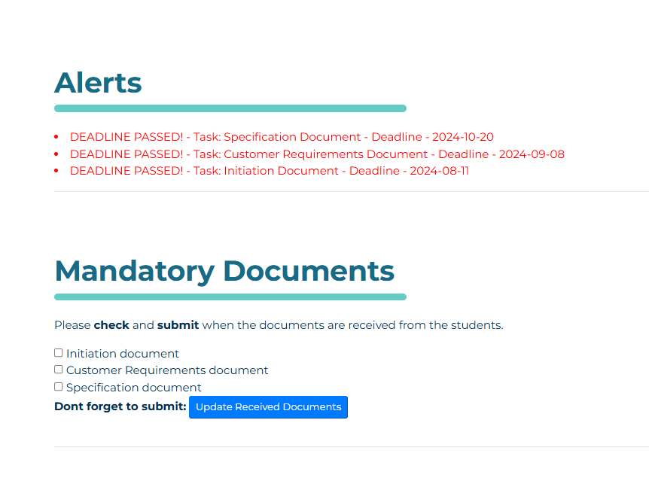

Each project must present 3 development documents and mark them as sent to the supervisor.

As soon as the supervisor receives them, he must mark them as such. Otherwise, the site administrators will understand that the project has not been initiated/has not progressed as planned according to the milestones.

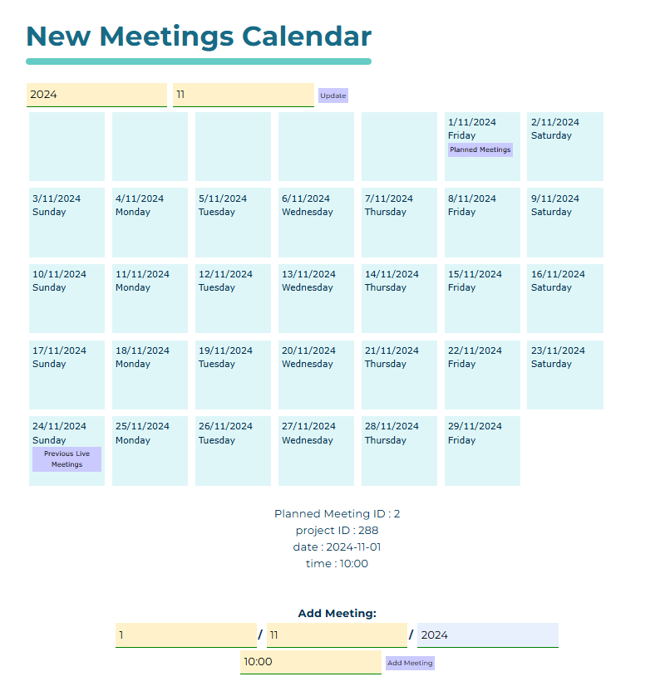**Feature 11:** Meetings – MEETINGS.

On the meetings page you can see a meeting calendar opened by Eliel (without using an external library).  
You can plan future meetings and see meetings that have taken place - by clicking on the day of the month.  
The LIVEMEETINGS mechanism starts a meeting live - and students need to confirm on MY PROJECTS page that they are in the meeting.  
Through MY PROJECTS page they can also see the link to Zoom (assuming the instructor uploaded a link to the site).  
On PREVIOUS LIVE MEETINGS page you can see who attended the meeting.

**Feature 12:** PROGRESSION.

You can see in a pie chart the number of tasks that completed by each student (out of several tasks he had). In addition, we can see how many meetings he attended out of the number of meetings in the project.  
You can see in a pie chart the number of tasks completed by each student out of the total tasks assigned to him.  
The page is updated regularly after each completed meeting/task.

This page provides great value to the administrators of the system and the supervisors, we can monitor the student's grade, understand the involvement of each of the participants, as well as the supervisor's conduct.

Perfect student.1

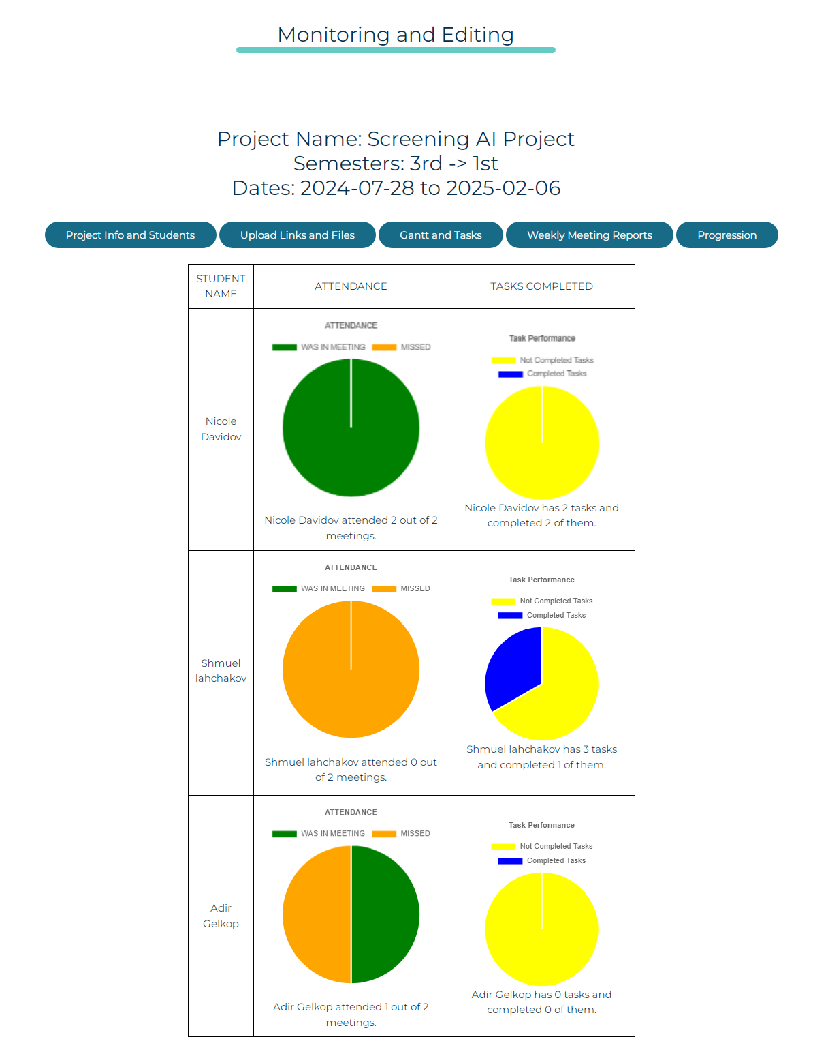2. Student with a lack of tasks and a lack of attendance

3. Student with a lack of tasks who did not receive tasks and a lack of attendance

Under each pie chart, the student's status is written with the name