IoT-based energy monitoring system.
  - January 15, 2023

Overview

Project background and description
HIT, The Holon Institute of Technology is responsible for ensuring the proper functioning and management of its buildings and workshops, which house valuable and advanced technological equipment, appliances, air-conditioners, and other energy-consuming devices. Uncontrolled usage of these assets can lead to costly damage and repairs. To better manage energy consumption and costs, HIT requires a monitoring system that tracks energy usage and equipment status across all facilities. This will enable HIT to make data-driven decisions to optimize energy usage, reduce costs and ensure the equipment is functioning optimally.
An IoT-based system is the perfect solution for this purpose. An IoT-based monitoring system allows for real-time monitoring and control of energy usage and equipment status. By integrating IoT devices with the equipment and appliances in the buildings and workshops, the system can provide accurate and actionable data in real-time, which can be used to make data-driven decisions to optimize energy usage and reduce costs. Additionally, an IoT-based system enables remote monitoring and control, which allows HIT management to have oversight of energy consumption across all facilities without the need to physically visit the sites. This would increase the efficiency and flexibility of HIT's energy management. Additionally, the students from computer science and EEE bachelor classes at HIT will work on this project as part of project-oriented learning, this would provide a hands-on experience for the students and help them in their future careers.
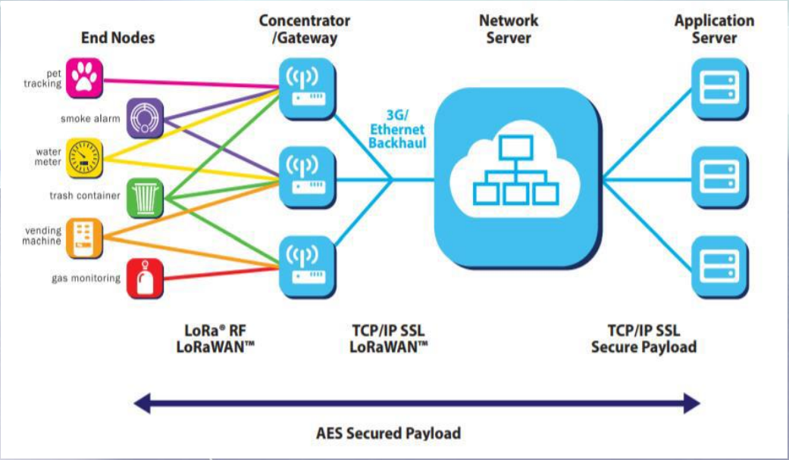
Figure 1: LoRa WAN Architecture

Project scope
The project scope is to develop and implement an internal IoT network that will collect data from energy supply and monitoring components and transmit their status in a comprehensive manner. The project will also involve the development and implementation of an application that will allow data recipients to receive information in real-time.

Targeted users
The primary beneficiaries of the project are the management and maintenance teams at HIT, who will use the system to optimize energy usage and reduce costs.

Planned usage
When a user logs into the system with an account and the necessary permissions, they will be presented with various data in different tabs, including:
- Human presence monitoring on campus.
- Remote control capabilities for lighting on campus.
- Data on the campus' solar power system energy production.
- Remote control for watering systems for campus gardens.
- Remote control and monitoring capabilities for campus air conditioning systems.
- Automatic, remote control capabilities for campus fans.
This data will allow the user to gain a comprehensive understanding of the system and perform basic actions such as setting usage goals, receiving notifications based on consumption, and more. However, users without an account will have limited access to the system, only being able to view general information such as the location of the institution and data on a quarterly or yearly level.
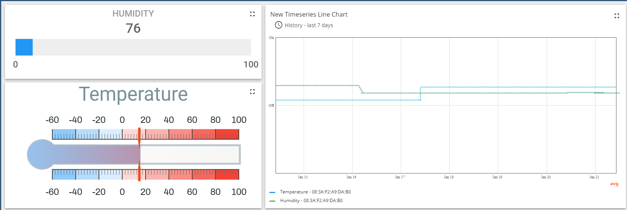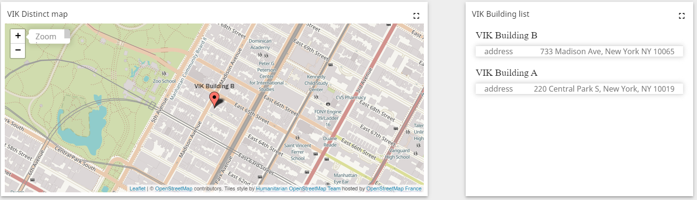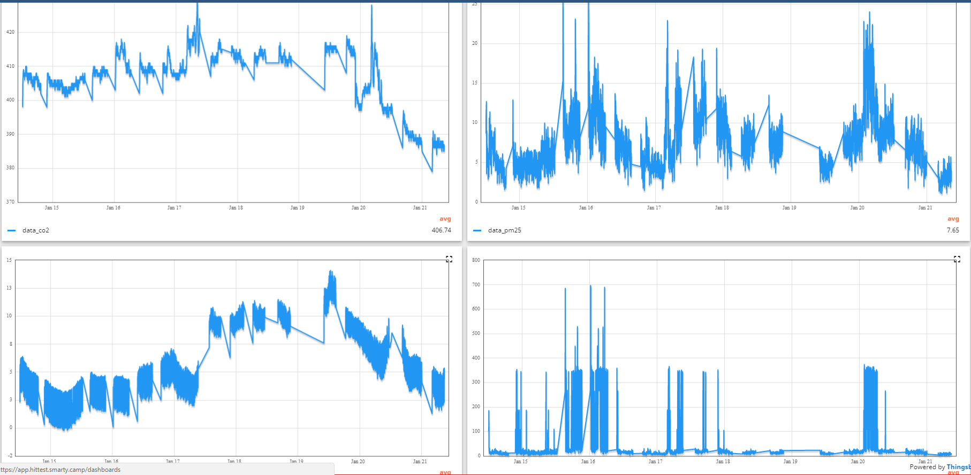
Figure 2: Dashboard UI simulation

Technology & Resources
- API (JS)
The project will use JavaScript Application Programming Interface to connect the client and server side.
- SQL Kona Gateway
SQL Kona Gateway will be used to manage the communication between the client and the database.
- Chipstack (Data server)
Chipstack will be used as the data server for the project, it will be responsible for collecting and storing data from different sources
- Thingboard (Application server)
Thingboard will be used as the application server, it will be responsible for managing the application's backend logic and providing access to the data stored in the data server.
- PostgreSQL (Database)
PostgreSQL will be used as the database management system, it will be responsible for storing the data collected from different sources in a structured manner.
- NodeJS API
NodeJS will be used to develop the API that connects the front-end with the back-end.
- React / Angular
React or Angular will be used for the front-end development, the choice will depend on the team's familiarity with the technology.
- HTML
HTML will be used for creating the structure of the web pages.
- CSS
CSS will be used to add styling to the web pages and make them more visually appealing.
The project team will consist of HIT students from the Computer Science and EEE Bachelor's degree programs, who will work on this project as part of project-oriented learning.
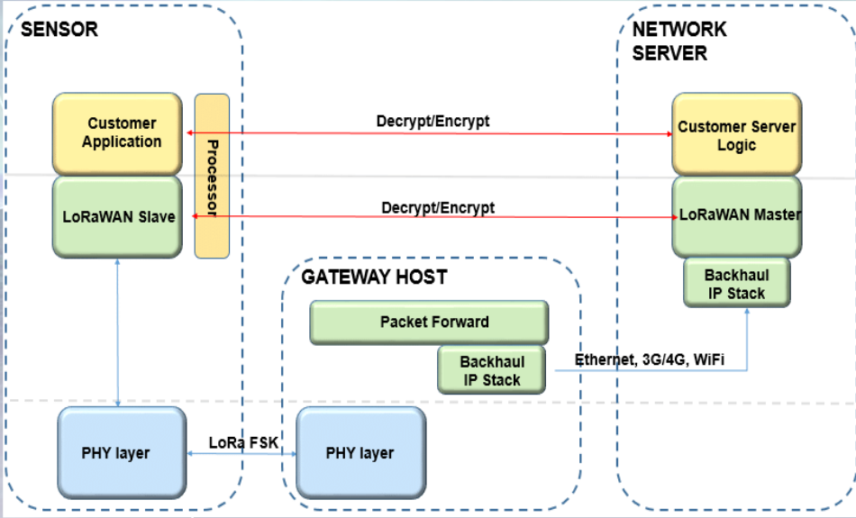
Figure 3: LoRa WAN detailed Architecture

Data base construction
Our database architecture will be designed to seamlessly integrate and store data from multiple sources, including but not limited to human presence monitoring, lighting systems, energy production from solar power systems, remote control of irrigation systems for campus gardens, air conditioning systems, and fan control.
The data collected will be used to gain insight on energy consumption, identify areas of improvement and optimize performance to reduce costs and increase efficiency.

Project requirements and execution
The project requirements will be divided into three main categories:
- Electrical and Electronics Engineering
Responsible for the planning and implementation of systems such as water, motion, and more.
This includes ordering the necessary equipment and building the sensors, as well as finally installing them on campus.
- Computer Science
Responsible for developing the application and interface through which all data collected by the systems will be passed.
- Design
Responsible for the overall design and aesthetic of the smart campus, both externally and internally.
The requirements will be executed through the integration of students from different faculties in sub-teams, working together remotely and through meetings at the institute. The project will face challenges such as obtaining the necessary materials on time, meeting deadlines, synchronizing between sub-teams, building a smart campus that is suitable for all seasons, testing sensors and systems to ensure accurate and reliable data transfer in real-time, and staying within budget. The project is also expected to be executed by HIT students, computer science and EEE bachelor classes as a part of project-oriented learning.

