Developing systems, algorithms and applications to enhance existing products. Creating a platform to manage IoT devices, enabling monitoring, management, and user support.  
Gaining practical experience in the development and understanding of the work processes in the integration of the industry

Work with platforms and professional tools that exist in the marketקבלת נסיון מעשי בפיתוח והבנת תהליכי העבודה בשילוב התעשייה

עבודה עם פלטפורמות וכלים מקצועיים הקיימים בשוק

The project involved the development of a comprehensive platform that enables control, support, and management of IOT components for both the company and its diverse customer base. The platform was designed to provide efficient and user-friendly functionality.

During the project, we were exposed to several important areas, including speech recognition, architecture planning, simulations, communication management, and integration testing. Each of these areas is important for the development of smart systems and new technologies.

The system we developed allows us to manage a smart home in a smart and efficient way. In addition, the system is able to identify unusual events and notify them as planned. protocols.

A smart server and dashboard for IoT internet products of the company's customers whose purpose is to collect and analyze data from connected devices in real time.

We also optimized using algorithms to improve the site's performance. We acquired practical experience in the company in diverse fields such as automation, server side development and client work with databases and algorithms.

שרת חכם ולוח מחוונים למוצרי אינטרנט IoT של לקוחות החברה שמטרתו לאסוף ולנתח נתונים ממכשירים מחוברים בזמן אמת.

כמו כן, ביצענו ייעול באמצעות אלגוריתמים לשיפור ביצועי האתר. רכשנו נסיון מעשי בחברה בתחומים מגוונים כמו אוטומציה פיתוח צד שרת ולקוח עבודה מול מסדי נתונים ואלגוריתמיקה .

In addition, we took care of security and privacy issues when developing IoT products. The devices in the home contain sensitive information about the residents and their lifestyles, so it is important to ensure that this information remains safe and protected against hacks and cyber-attacks. IoT product developers should consider advanced security capabilities such as exposing the information according to the node structures, effective identity verification, and viewing operation history to identify suspicious operations.

In developing an IoT product, we considered that the devices in the home can be diverse and come from different suppliers, so it is necessary to ensure that the devices speak the same language or protocol. Also, important. Plan the structure of the network and ensure a high capacity of the network at every point in the house to make sure that the devices can communicate appropriately and in real-time.

Development languages: Python programming language.

Version control: GitHub

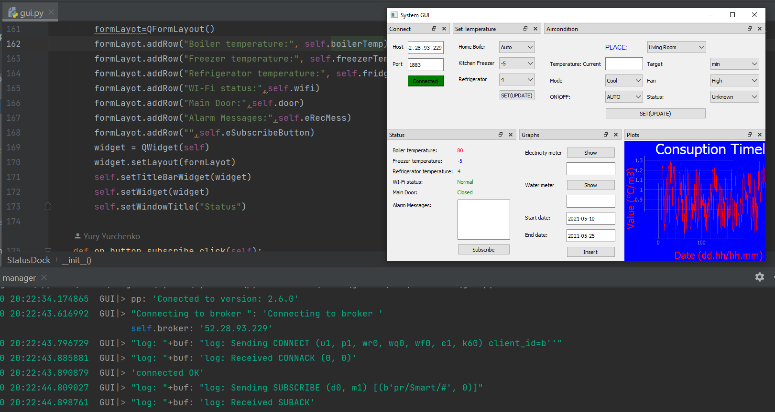

we conducted extensive research on platforms and interfaces. Our planning phase involved breaking down tasks and allocating resources accordingly. During the implementation stage, we developed and integrated various tasks. To ensure the system's robustness, we conducted comprehensive testing, meticulously evaluating its performance.

The application of the concept of a smart home was created by combining IOT services and cloud computing. Information was embedded in sensors and actuators with the assistance of a miniature computer and connectivity to smart components was achieved using the MQTT communication protocol.

Final project

Smart home controlled by BOT

<OriginGps &Yuri Yurchenko>

Adar Kabada

313296279

Gila Aweke

320430218

Yury Yurchenko (Faculty of Sciences, HIT)

